

Programme | : | M.Tech Int Software Engineering | Semester | : | Fall 2026-2027
Course | : | Database Systems Lab | Code | : | IASWE206
Faculty | : | Dr. M. Premalatha | Slot | : | L31+L32
NAME:A.Nathan Anthony
REG NO:25MIS1113
Ex. No. 3
Date: 20-07-2026
SQL Basics – Integrity Constraints

Note:
LMS Submission Format [Word File]
Regno, name
Course code, course title
Slot
Faculty Name
Question
SQL Query – Text Format (Copy Paste)
Screenshot

Ex:
Question:
create a student table with attributes regno, name, mobno and dob with appropriate datatypes and sizes

Query:
SQL> create table student_mp(regno varchar(4), sname char(10), mobno number(10), dob date);
Table created.

Screenshot:

SQL> desc student_mp
Name Null? Type
----------------------------------------- -------- ------------
REGNO VARCHAR2(4)
SNAME CHAR(10)
MOBNO NUMBER(10)
DOB DATE
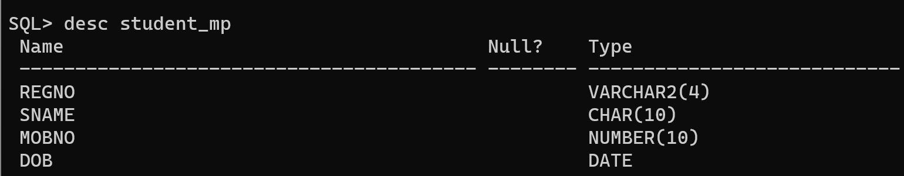

- Books Table:
  - isbn – primary key
  - title
  - price
  - qty – not null
- Authors Table:
  - Author_id – primary key
  - email - unique
- Book_Authors:
  - isbn – foreign key references books table
  - author_id – foreign key references authors table

- Create the above tables and apply constraints as specified during the creation of the table.

Query:

SQL> create table books(isbn varchar2(13)primary key,title varchar2(100),price number(8,2),qty number(3) not null);

Table created.

SQL> create table authors(author_id number(3) primary key,author_name varchar2(50),email varchar2(100) unique);

Table created.

SQL> create table book_authors(isbn varchar2(13),author_id number(3),constraint fk_book foreign key(isbn) references books(isbn),constraint fk_author foreign key(author_id)references authors(author_id));

Table created.

SQL> desc books;
Name Null? Type
----------------------------------------- -------- ----------------------------
ISBN NOT NULL VARCHAR2(13)
TITLE VARCHAR2(100)
PRICE NUMBER(8,2)
QTY NOT NULL NUMBER(3)

SQL> desc authors;
Name Null? Type
----------------------------------------- -------- ----------------------------
AUTHOR_ID NOT NULL NUMBER(3)
AUTHOR_NAME VARCHAR2(50)
EMAIL VARCHAR2(100)

SQL> desc book_authors;
Name Null? Type
----------------------------------------- -------- ----------------------------
ISBN VARCHAR2(13)
AUTHOR_ID NUMBER(3)

Screenshot:
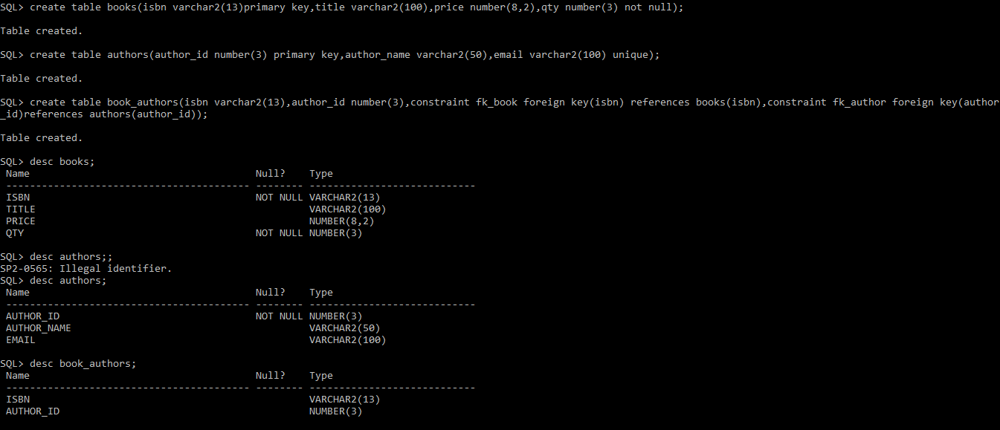

- For the already created books table, Add unique constraint to title
Query:

SQL> alter table books add constraint uk_books_title unique(title);

Table altered.

SQL> desc books;
Name Null? Type
----------------------------------------- -------- ----------------------------
ISBN NOT NULL VARCHAR2(13)
TITLE VARCHAR2(100)
PRICE NUMBER(8,2)
QTY NOT NULL NUMBER(3)

Screenshot:
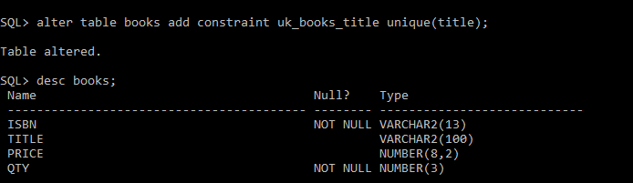
- For the already created books table Add not null constraint to price
Query:

SQL> alter table books modify price number(8,2)not null;

Table altered.

SQL> desc books;
Name Null? Type
----------------------------------------- -------- ----------------------------
ISBN NOT NULL VARCHAR2(13)
TITLE VARCHAR2(100)
PRICE NOT NULL NUMBER(8,2)
QTY NOT NULL NUMBER(3)

Screenshot:
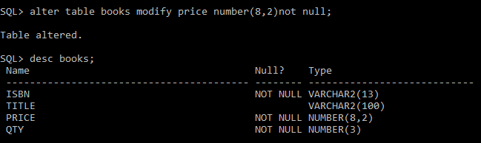
- Alter not null constraint in price attribute in books table and set the check constraint so that value is greater than 0.0
Query:

SQL> alter table books modify price number(8,2)constraint chk_books_price check(price>0);

Table altered.

SQL> insert into books values('9780134685991','Database Systems',0.0,12);
insert into books values('9780134685991','Database Systems',0.0,12)
*
ERROR at line 1:
ORA-02290: check constraint (SYSTEM.CHK_BOOKS_PRICE) violated

Screenshot:
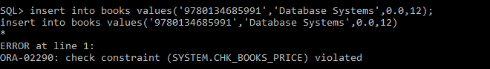
- Drop not null constraint for qty in books table
Query:
SQL> alter table books modify qty null;

Table altered.

SQL> desc books;
Name Null? Type
----------------------------------------- -------- ----------------------------
ISBN NOT NULL VARCHAR2(13)
TITLE VARCHAR2(100)
PRICE NOT NULL NUMBER(8,2)
QTY NUMBER(3)

Screenshot:
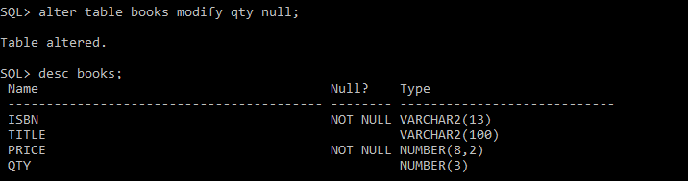
- Set a default value of qty in books table as 0
Query:
SQL> alter table books modify qty default 0;

Table altered.
SQL> insert into books(isbn,title,price) values('9780134685991','Database Systems',1200.0);

1 row created.

SQL> select*from books;

ISBN
-------------
TITLE
--------------------------------------------------------------------------------
PRICE QTY
---------- ----------
9780134685991
Database Systems
1200 0

Screenshot:
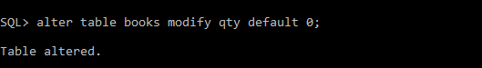
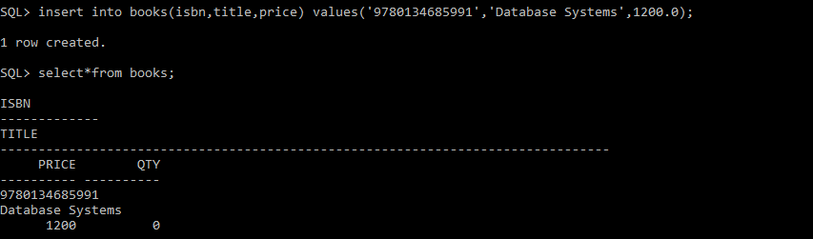
- Drop unique constraint for email attribute in authors table
Query:
SQL> select constraint_name,constraint_type from user_constraints where table_name=upper('authors');

CONSTRAINT_NAME C
------------------------------ -
SYS_C007022 P
SYS_C007023 U

SQL> alter table authors drop constraint SYS_C007023;

Table altered.

SQL> desc authors;
Name Null? Type
----------------------------------------- -------- ----------------------------
AUTHOR_ID NOT NULL NUMBER(3)
AUTHOR_NAME VARCHAR2(50)
EMAIL VARCHAR2(100)
Screenshot:
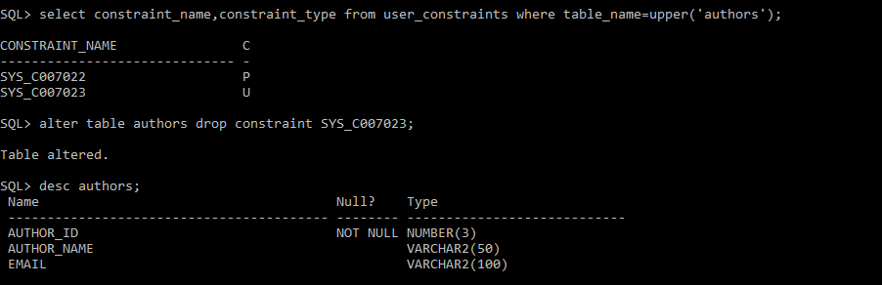

- Drop any one foreign key constraint.
Query:
SQL> alter table book_authors drop constraint fk_book;

Table altered.

SQL> desc book_authors;
Name Null? Type
----------------------------------------- -------- ----------------------------
ISBN VARCHAR2(13)
AUTHOR_ID NUMBER(3)
Screenshot:
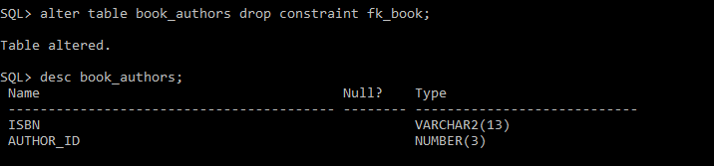
- Drop a primary key [after referenced foreign key is dropped]
Query:

SQL> alter table books drop primary key;

Table altered.

SQL> desc books;
Name Null? Type
----------------------------------------- -------- ----------------------------
ISBN VARCHAR2(13)
TITLE VARCHAR2(100)
PRICE NOT NULL NUMBER(8,2)
QTY NUMBER(3)

Screenshot:
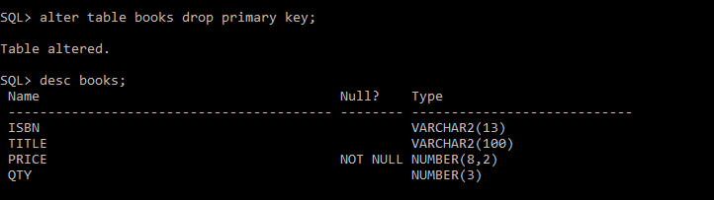
- Add an attribute for authors table and set a constraint for it.
Query:

SQL> alter table authors add phone number(10);

Table altered.

SQL> alter table authors add constraint chk_phone check(phone>=1000000000);

Table altered.

SQL> desc authors;
Name Null? Type
----------------------------------------- -------- ----------------------------
AUTHOR_ID NOT NULL NUMBER(3)
AUTHOR_NAME VARCHAR2(50)
EMAIL VARCHAR2(100)
PHONE NUMBER(10)

SQL>insert into authors values(101,'j.k.rowling','jkrowling@gmail.com',894095810);
insert into authors values(101,'j.k.rowling','jkrowling@gmail.com',894095810)
*
ERROR at line 1:
ORA-02290: check constraint (SYSTEM.CHK_PHONE) violated
Screenshot:
